**Use Cases**

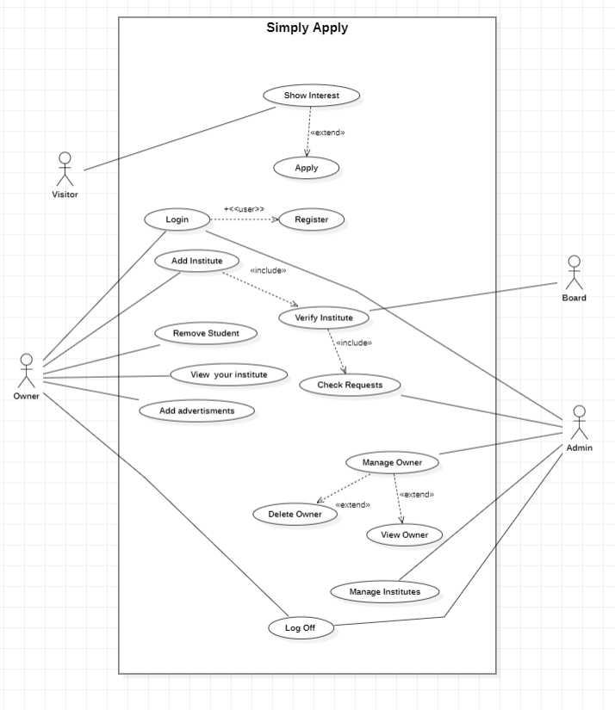

**Brief Use Case:**

**Visitor:**

Firstly Visitor visit this website for admission or for gaining information then they will select the institute and will apply.

**Owner:**

If the visitor is an owner then the owner will add your institutes. After adding the institute, they will view your page, remove students and add advertisements.

**Board:**

When the owner wants to add an institute so their request will be sent to the board office. If that institute adds with the board so the board will verify their request.

**Admin:**

The adding institute request will go to admin and Admin will accept their request or reject the request. Admin will manage all institutes and owners.

**Full-Dressed Use Case:**

Firstly visitors (students) will search simply apply on search engines (Google, Microsoft Edge, fire Box, etc) then they will visit this website, and click on select institutes, so then they select your choice (Schools, Colleges, and academies). When they select your choice, they will view different schools, colleges, or academies. And they will easily apply to your choice. When students will apply so their admission forms will be sent to their choice (Schools, Colleges, and Academies). Before ac­cepting or rejecting the admission. Principals will send the request to the admin to add my institutes. The request will also send to Board. If the board verified the institute then Admin will accept the request otherwise will be rejected. When institute requests will be accepted then Principals of schools, colleges, and academies will accept or reject the admission. And principals could visit your institute page and can add advertisements.